 | Accuracy | Recall |  | F1 Score |  | Precision
 | overall | 0 | 1 | 0 | 1 | 0 | 1
Random Forest | 0.98 | 1.00 | 0.61 | 0.99 | 0.76 | 0.98 | 0.99
Boosting
Adaboost | 0.96 | 0.97 | 0.80 | 0.98 | 0.68 | 0.99 |  | 0.59
Gradient Boosting | 0.97 | 0.99 | 0.97 | 0.98 | 0.73 | 0.99 |  | 0.67
XG Boost | 0.97 | 0.98 | 0.77 | 0.98 | 0.70 | 0.99 |  | 0.64
Oversampling
SMOTE | 0.98 | 1.00 | 0.68 | 0.99 | 0.80 | 0.98 |  | 0.99
ADASYN | 0.98 | 1.00 | 0.65 | 0.99 | 0.79 | 0.98 |  | 0.99

GRAPHS
PLOTS FOR MISSING VALUES

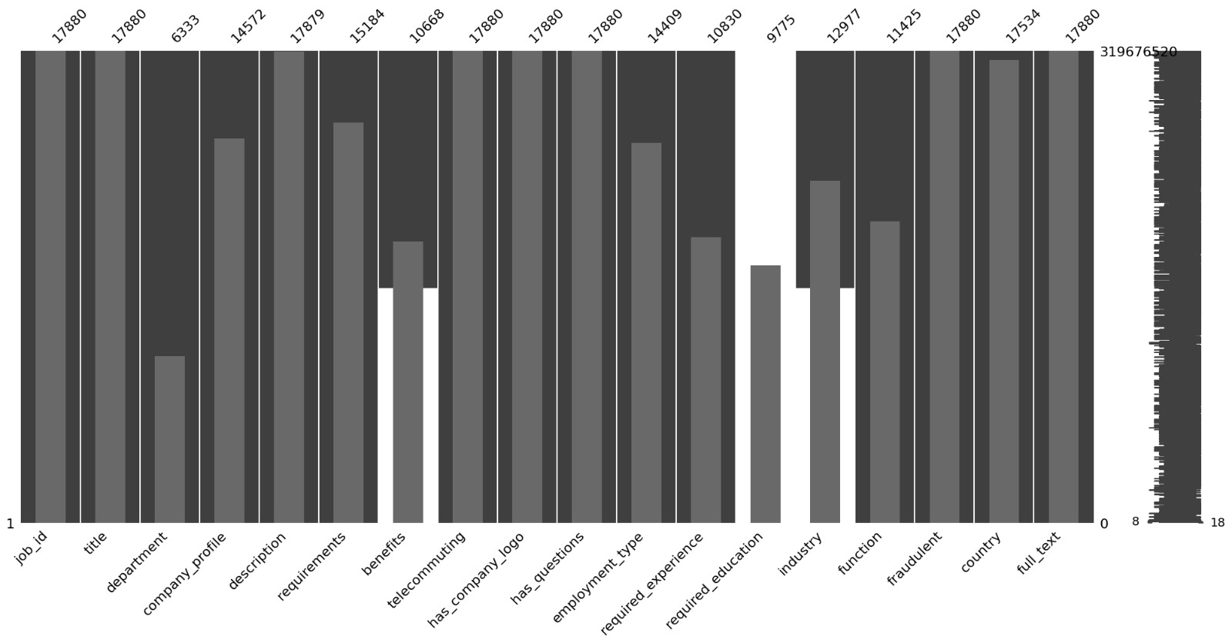
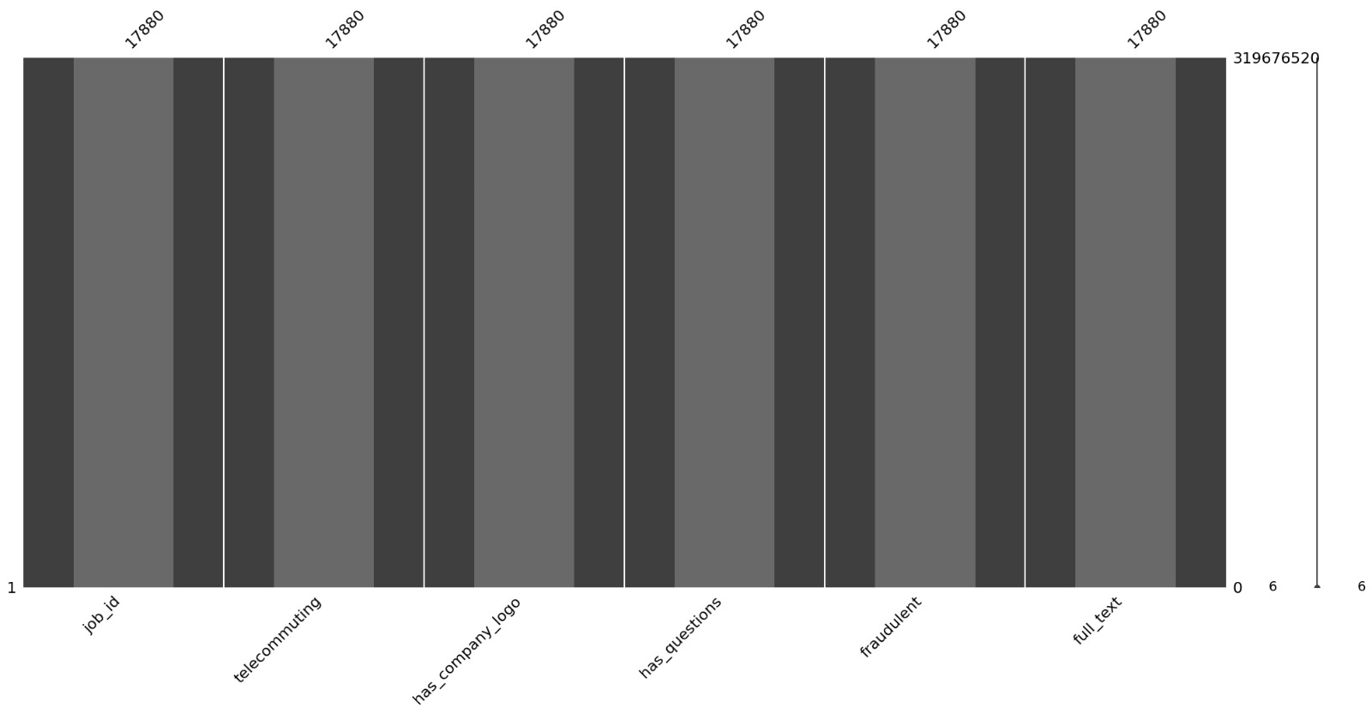

*REQUIRED EDUCATION VS FRAUDALENCE

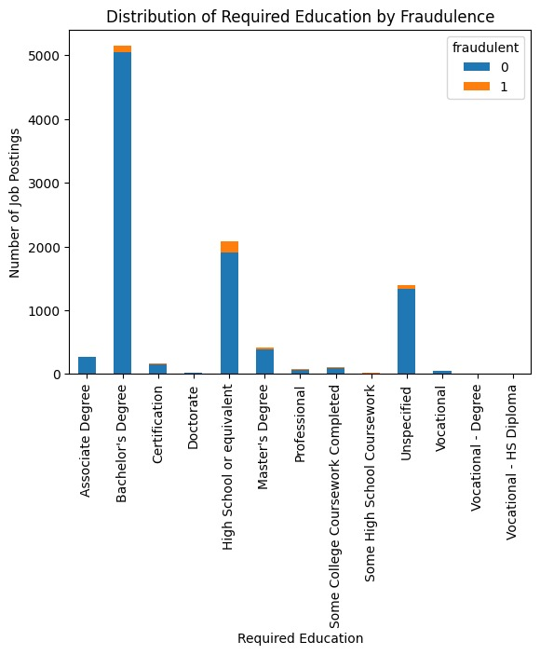

EMPLOYEMENT TYPE DISTRUIBUTION

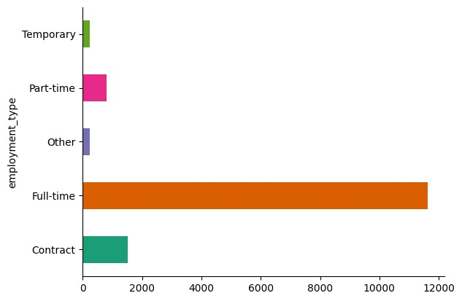

*EMPLOYEMENT TYPE VS REQUIRED EDUCATION

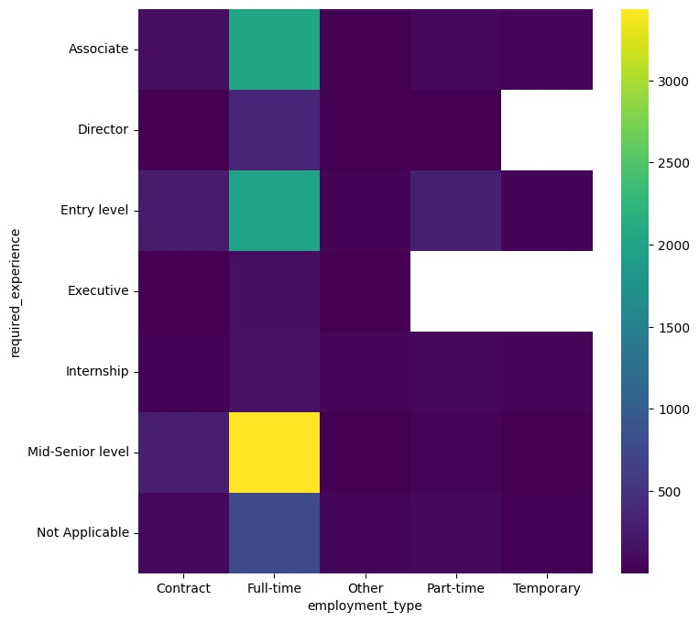

*JOB ID VS FREQUENCY

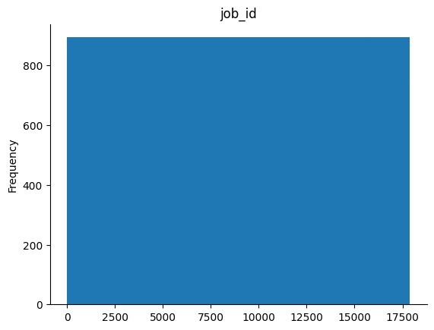
*EMPLOYEMENT TYPE DISTRIBUTION
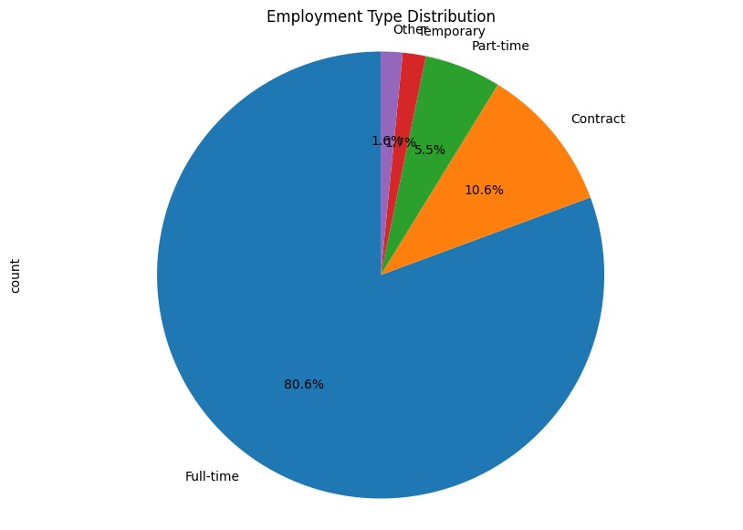

FRAUDLENT JOBS VS JOB INDUSTRY
